**Vaya Configuration Tool**

**User Manual V1.0.0**

**1. Introduction**

Vaya Configuration Tool is designed for parameters configuration and fixture test during manufacturing from Philips Solid-State Lighting Solutions.

Together with Smart Jack Pro, it can be set up a test and configure station for Philips Vaya Series Lighting Fixture which compatible with RDM and DMX protocol.

This tool has below features:

1. Generate the first UID of the day

2. Set fixture UID and model description based on Vaya Profile file

3. Simple test for testing the communication station on the RS485 bus

**2. Function Description**

**2.1 User Interface**

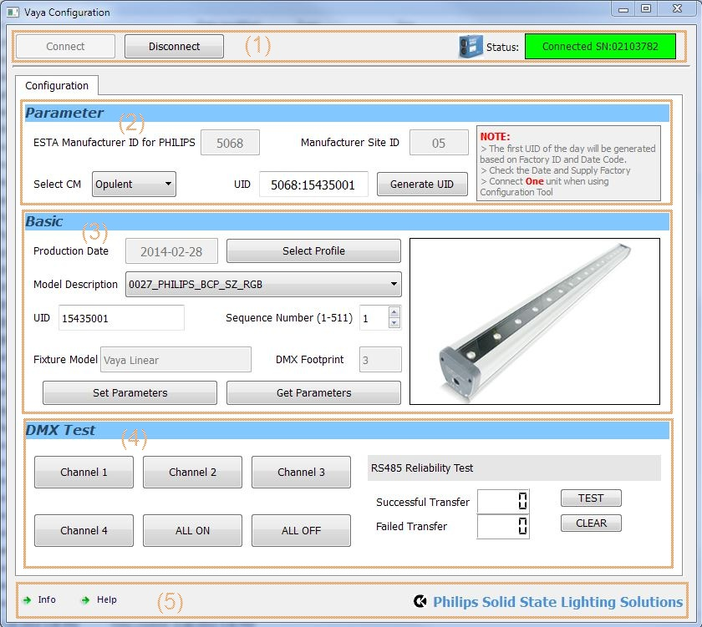

The software divided into 5 parts:

1) Connecting the Smart Jack Pro

2) Generate the UID

3) Set and Get the parameters to/from the unit

4) Simple channel test

5) Software information

**2.2 Connect the Smart Jack Pro**

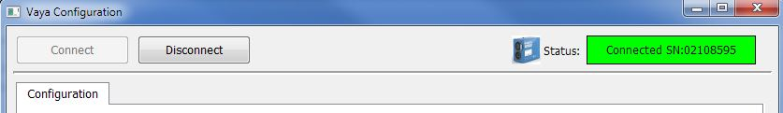

Click the Connect button, the software will try to connect the Smart Jack pro via Visual COM, so you have to install the FT245BM Driver before use. And the software only supports one device. Please don’t plug more than one SJP into the computer.

When successfully connected, the SJP logo will display colored and show the SJP Serial number in GREEN box.

Click the Disconnect button, the software will disconnect the device and logo will appear grey.



**2.3 Generate UID**

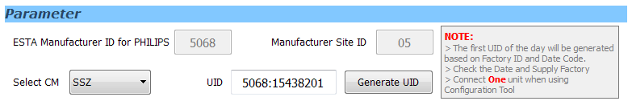

In this part, software will generate the first UID according to below information:

1. PHILIPS ID: this is fixed at 5068 for PHILIPS

2. Manufacturer ID: this is fixed at 05 for PHILIHPS

3. CM ID: choose the correct CM ID based on the product

4. The production date

CM can use this UID to print the SN label, and the SN program in the fixture memory

**2.4 Setting the parameters**

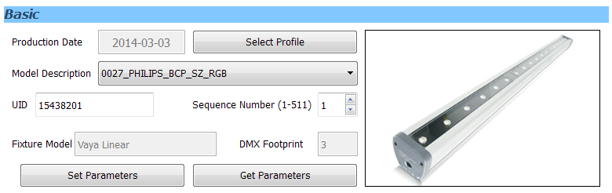

In this part, operator will select the correct fixture profile and sequence number to program it into the fixture memory.

1. Select correct profile which is match to the firmware.

2. Choose correct model, default is the RGB model

3. Set the correct sequence number, this number will be sync with the UID and arrange from 1 to 511.

4. Click the “Set Parameters” button, software will send command and set the parameters into the fixture.

5. Click the “Get Parameters” button, software will read back the parameters from fixture.

**2.5 Fixture Test**

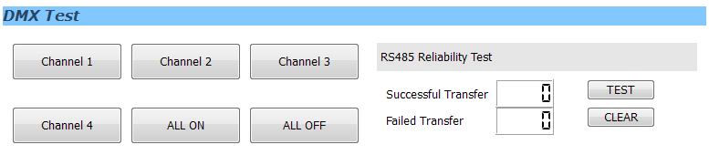

Fixture Test is divided into 2 parts. The left part is channel test, operator can click the button to turn on the LED channel to check whether the output is normal or not.

The right part is the communication test which will test the RS485 and firmware communication function by sending RDM command.

**2.6 Information**



In this part, user can check the software version and user manual by click the button. User can get the support by the displayed information. If you encounter any software issue, please contact [simon.dl.he@philips.com](mailto:simon.dl.he@philips.com) for support.

